Swachhata Hi Seva-2018
ICAR-Central Inland Fisheries Research Institute, Barrackpore, Kolkata
Day 4: 19.09.2018
A series of activities such as speech, experience sharing and recitation on swachhata was organised by CIFRI under leadership of Dr. U. K. Sarkar, HoD RWF division. He stressed upon the community awareness to reach the citizen of the country starting from the local people. Other speakers Dr. Archana Sinha, Dr. M.A. Hassan also joined Dr. Sarkar in implementing Swachh Bharat mission in real sense in the urban as well as in the rural areas. Dr. Suman Kumari recited a poem on this occasion.
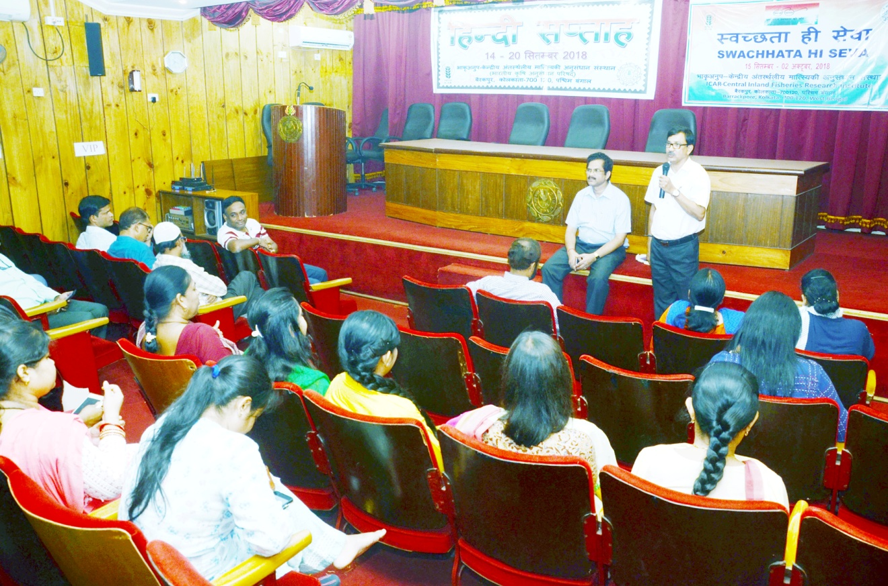
The Swachhata Shram session was conducted at Mahadevananda Vidyaayatan, Barrackpore where Dr. A. K. Das, Principal scientist CIFRI described the importance of celebration to the students of the school, future of the country. School teachers have also actively participated in the campaign programme. Following this, the school premises were cleaned and sanitized with bleaching powder.

